**Introduction to MaxQDA for Qualitative Data Analysis**

**Objective:**

By the time we are finished, you will know how to add, manage, and analyze data using MaxQDA.

**Background:**

We will use a sample project that looks at environmental change in coastal communities called “Environmental Change Down East.” This example came from an NVivo example project. We use the same data in our qualitative software workshop series so participants can easily compare the leading qualitative data analysis software packages. Respondents were asked six overarching questions/topics. We will focus on the ***reasons for the decline in the fishing industry down east***.

**Let’s begin!**

1. Download CCSSMaxQDA Workshop files
   1. Go to <https://cornell.box.com/s/pucc3042twvkl6y13mdbsuod0h2tdwgr>
   2. You may be prompted to enter your netid and password
   3. Click on the ellipses button (…) and select Download
   4. The CCSSMaxQDA.zip will be downloaded to your default Downloads folder
2. Unzip the CCSSMaxQDA.zip onto your local drive.  Choose to unzip it as a CCSSMaxQDA folder.   Rename the folder as MaxQDAProject.
3. This folder contains the files and handouts we will use in the Workshop.
4. Click *Start*>*MaxQDA* 2024>*MaxQDA 2024*
5. Familiarize yourself with the options on the welcome interface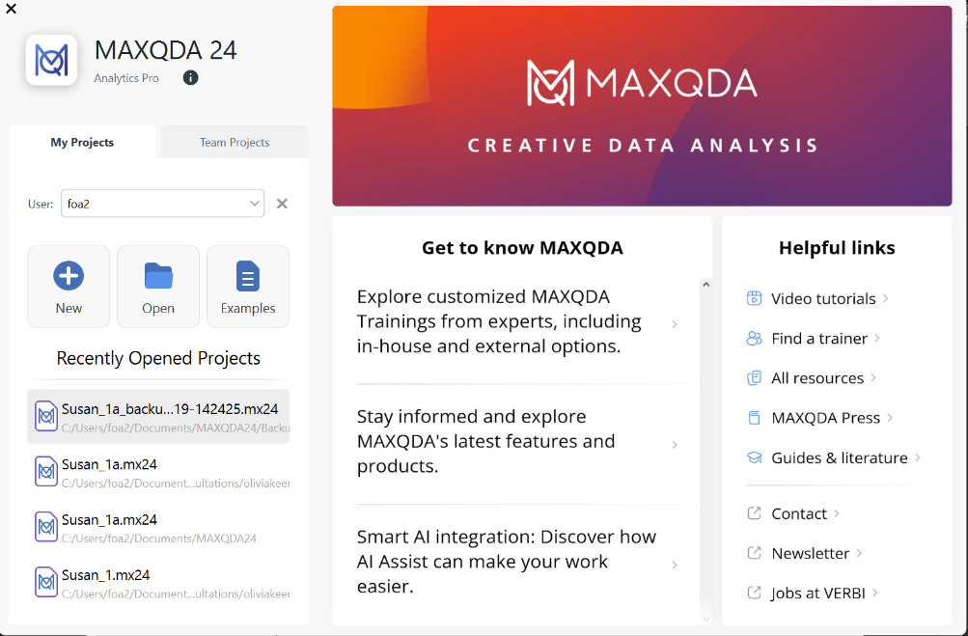
6. Choose *New*; name it *Training.*
7. Click *Save.*
8. Familiarize yourself with the Ribbon, Document System, Code System, Document Browser, and Retrieved segments.

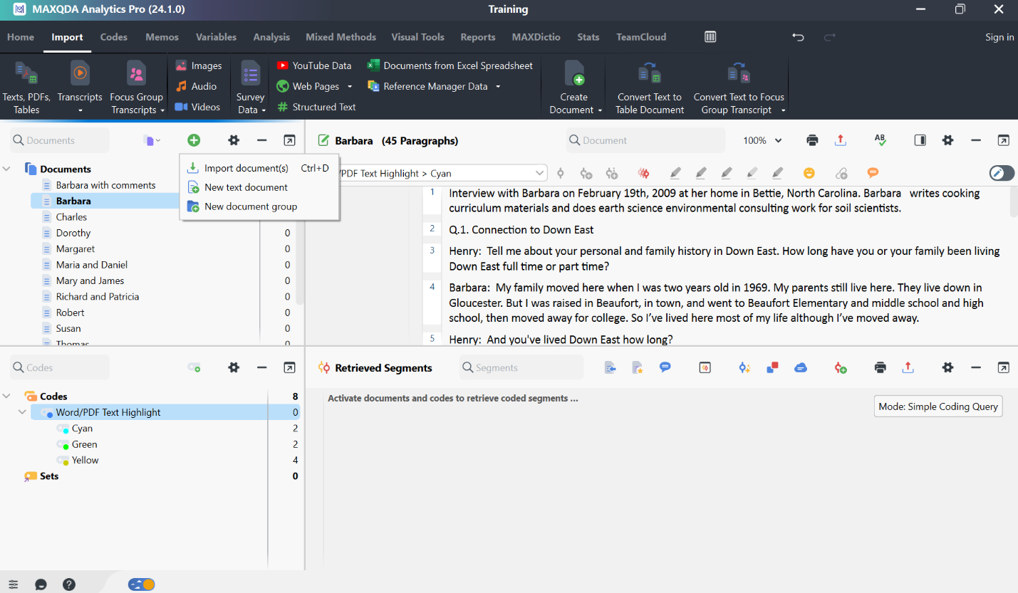

1. Add files – click *Import> Texts, PDFs, Tables*>Go to the *MaxQDAProject* folder, select all Word files **except** Barbara, Charles, and Maria and Daniel, then click *Open*
2. View file contents – Double-click on the *Patricia and Richard* file. This displays the transcript content.
3. Familiarize yourself with the structure of the interview and the format of the transcript
4. **Coding** is gathering materials by topic, theme, or case. For example, you go through each document and select text passages, video clips, or audio clips that talk about the decline in the fishing industry due to environmental impacts, and you code (or tag) each passage *due to environmental impacts*. You can then gather all the passages with that code to look for emerging patterns and ideas.

Types of coding

a) Open Coding, in-vivo coding, Code with existing code

b) Emoticoding

c) Color Coding

12. Open ***Patricia and Richard’s***  interview transcript: Scroll down to Q4 locate the highlighted passages and follow the coding method below:

1. Code all Teal highlighted passages as *Due to regulations*

**Coding Method 1:** Highlight passage>right-click>*With New Code*>Name the code *Due to regulations,* then click *OK.*

Note the following:

1. Options: Color, Code Memo, Comment on the coded segment, and Additional code
2. Code System panel: *Due to* *regulations* now listed.

**Coding Method 2:** Highlight the other passage that needs to be coded as *Due to regulations*. Then drag and drop into the *Due to regulations* code in the Code System panel.

13. Open ***Susan’s*** Interview transcript: Scroll down to Q4 and locate the highlighted passage and follow the coding method below:

**Coding Method 3:** Highlight passage>Go to the document toolbar>select Code with a new code> name it *Due to water quality decline,* then click *OK*.

14. Import Barbara, Charles, and Maria and Daniel’s transcripts

Open **Barbara’s** transcript. Scroll down to Q4, locate the highlighted passages, and follow the coding method below.:

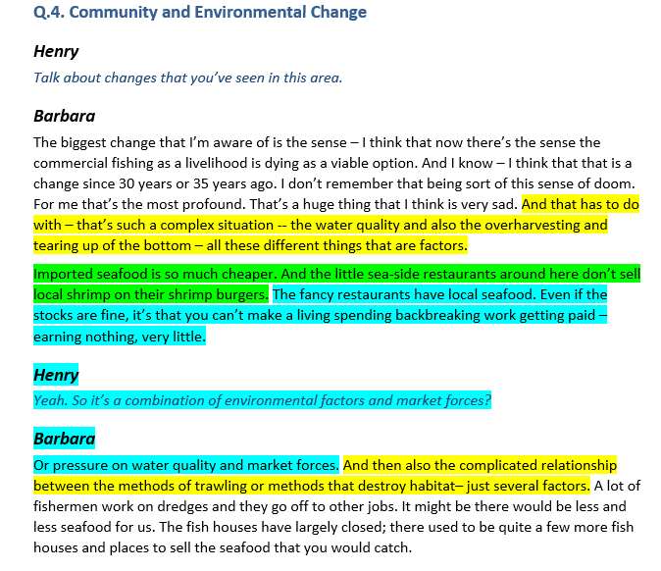

* + 1. All Yellow highlighted passages rename as *Due to environmental impacts of fishing*
    2. All Bright-Green highlighted passages rename as *Due to foreign competition*
    3. All Turquoise highlighted passages rename as *Due to cost of doing business*

To rename a code, right-click on the code in the Code System panel, click Rename Code, and enter the new name.

Or, lightly tap (single-click) the code in the Code System Panel; this puts the name in edit mode, then enter the new name

1. Open **Charles’** transcript: Scroll down to Q4, locate the highlighted passages, and follow the coding method below.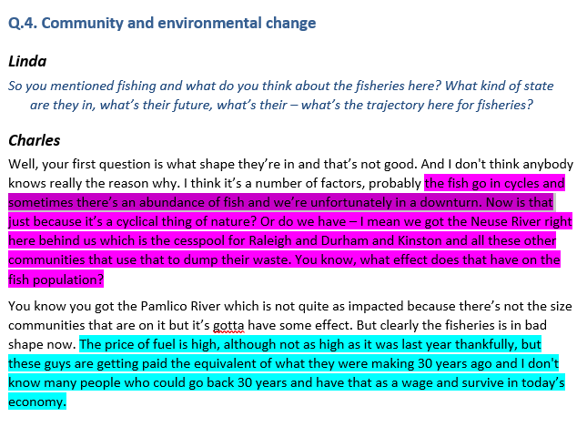
   * 1. All Pink highlighted passages rename as *Due to natural variation*
     2. All Turquoise highlighted passages are now coded as *Due to cost of doing business*
2. Open ***Maria and Daniel’s*** interview transcript: Scroll down to Q4, locate the highlighted passages, and follow the coding method below.:

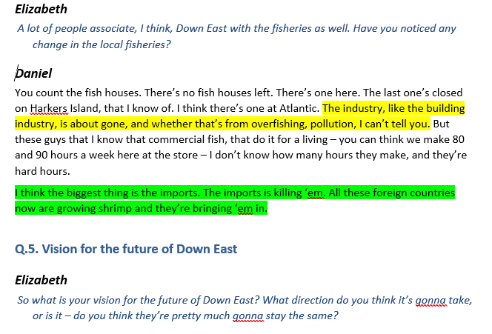

* + 1. All Yellow highlighted passages are now coded as *Due to environmental impacts*
    2. All Bright-Green highlighted passages are now coded as *Due to foreign competition*

1. **Creating Free Codes**



**Coding Method 6:** Go to the *Code System panel*>select *New Code* > name the code*,* then click OK.

**Coding Method 7:** Go to the *Codes Menu*>select *New Code* > name the code, then click OK.

1. **Saving project**
   1. MAXQDA does not have a “save” button. Once an action is performed, it’s immediately saved. It is also why MAXQDA double-checks before deleting essential project elements, such as codes.
   2. Documents and memos currently being edited, for example, when writing notes in a text document or transcribing audio/video files, are automatically saved every 5 minutes. This time interval can be adjusted in the project settings. Open maps in MAXMAps are automatically saved every minute and when they are closed. Logbook entries are saved when you close the logbook window.
2. **Project file backups**
   1. It is strongly recommended that you regularly create project backups and save them on external hard drives or flash drives to minimize losses in case of computer problems. Backup files should not be stored in the same location as your computer.
   2. MAXQDA 2024 project files have the extension MX2024 – if the file extensions are hidden in your computer system, you can recognize the files by the MAXQDA icon and the file type “MAXQDA 2024 Project File”.
   3. You can transfer your MAXQDA project files to an external storage drive using Windows Explorer or Mac Finder. Alternatively, open the file in MAXQDA and choose **Home > Save Project As** in the top menu. Then specify a location and file name and click **OK**.
   4. MAXQDA allows you to back up projects automatically. If you open a project that MAXQDA has not backed up for more than a day, MAXQDA will save a copy in a selected folder. MAXQDA automatically provides the backup file with a date and time stamp.
   5. Both the time interval after which a project should be automatically saved, and the directory for backup copies can be specified in the MAXQDA preferences. Open these preferences by clicking on the gear symbol in the upper right corner of the MAXQDA window. There, you can also disable the function entirely.

1. **View retrieved segments** – Activate documents and codes to retrieve coded segments.

In the Codes System panel, click the code icon next to *Due to environmental impacts to activate the code.*

In the Document System panel, click on the document icon next to the *Barbara* transcript to activate the document.

This will open the coded segments in the Retrieved Segments panel.

Familiarize yourself with the tools in the Retrieved Segments panel.

1. **Working with Audio recordings or video footage**

*Editing audio or video files -* Do the video or audio editing outside MaxQDA using an editing software BEFORE adding it to MaxQDA.

Audio and video files are generally not imported directly into a MAXQDA project. Instead, they are stored in the MAXQDA Externals folder and linked to a text document in which you can, if necessary, save a transcript.

*Click Import>Videos:*

* + - Select *Betty and Paul*

* + - And link its transcript – Betty and Paul_otter.ai

In the “Document System,” you will recognize a text document with the associated media file by its special symbols: a musical note for audio files and a video camera for video files. This file is empty if the audio/video file you imported does not have a corresponding transcript. But you can transcribe it in this empty file.

Note: If the association between the video/audio and its corresponding transcript did not work, in the Document System, right-click on the transcript and select Link Audio/Video file, insert time stamps automatically if the transcript has a time stamp, and click OK.

* + - Open the transcript and click on the audio/video icon to view
    - Click *Play* or drag the slider up to the beginning of the selected clip, then hit *Start of clip selection*
    - Let it play until the end of the selected clip, then hit *End of clip selection*
    - Right-click on the selected clip, then code it

*To code audio files:*

* Process is the same as in video files. Try it with the *Helen* file.

1. **AI Assist**
2. **Document**

**Summarize Document**

In the Document System, right-click on Barbara, select AI Assist>Summarize Document

**Chat with this Document**

In the Document System, right-click on Barbara, select AI Assist>Chat with this document

Type: What are the environmental changes down east?

**AI Coding (Beta)** – create coding suggestions for the selected document

In the Codes System, create a new code called: Reasons for the decline of the fishing industry

In the Document System, right-click on Barbara, select AI Assist>AI Coding (Beta)

Drag the code “Reasons for the decline of the fishing industry”

Code definition

Codes statements where interviewees discuss reasons for the decline of the fishing industry

Inclusion criteria

Statements that discuss reasons for the decline of the fishing industry

1. **Selected Text**

In the Document System, double-click on Charles to open it.

Highlight the entire Q.4 section

Right-click on the selected segment, then choose AI Assist>Suggest new codes for selected text

Select the relevant suggestions, and hit OK

1. **Codes**

Find all Q.4 blocks, and code them as “Community and Environmental Change”

Check the “click a code to apply the code to a selected segment” in the Codes System Settings when coding

Right-click on the code, select AI Assist, and try the following:

* + - * 1. Chat with this code’s segments
        2. Suggest Subcodes
        3. Summarize coded segments

1. **Retrieved Segments**

**Retrieve segments coded as “Community and Environmental Change”**

**Select the tool “Chat with listed text Segments”**

**Type Summarize the community and environmental changes down east**

1. **Explore and Autocode data**
   1. **Text Search & Autocode** (find the occurrence of a word, phrase, or concept)

Click ***Analysis>Text Search & Autocode>Text Search & Autocode***

Enter *fish* in the *New entry* box

Leave the rest of the settings as is

*Run search*

A Search results window will open with all occurrences of fish.



Familiarize yourself with the tools in the Search results window.

Click Columns, and check only Preview and Document Name.

Click on the Excel spreadsheet to export the results to Excel.

Click on *Autocode Search Results with a new code*, accept the default name, click OK, then select Paragraph under “Text and table documents.”

Another option is to click on *Autocode Search Results* and then select from the existing list of codes (at least one existing code must be activated)

* 1. **Extended Text Search**

Search for keywords within a particular context, for example, *fish* and *place* within one paragraph.

Let’s search for the words **fish AND place Within 1 Paragraph**

Click on the *Documents* folder to activate all documents

Activate *Autocode – ANY: fish*

Click ***Analysis>Text Search & Autocode>Extended Text Search***

Enter *fish place* in the “Include all these search items” box

Select *“In activated documents.”*

*Within 1 paragraph*

Click *Run Search*

* 1. **Coding Query.** Facilitates retrieval of coded segments.

Activate selected documents

Activate selected Codes

Click *Analysis>Complex Coding Query>Coding Query>Start*

Click *Analysis>Complex Coding Query>Complex Coding Query*

*fish*

*fish and place*

Notice the query is working already --check the Segments found section. Click *Start* to display Retrieved Segments.



* 1. **Comparing Documents and Codes** – Compare Cases and Groups can be used to compare the coded segments for different cases and groups. Codes are listed in the matrix rows, and cases or groups are in the columns.

Activate selected documents

Activate selected Codes

Click Analysis>Compare Cases and Groups>Qualitative

Click *Insert activated documents*

Click *Insert activated codes*

Click *OK*

In the Interactive Quote Matrix output, click on a code and observe what happens

**Now, try Quantitative (Crosstabs):**

Click Analysis>Compare>Quantitative

Click *Insert activated documents*

Click *Insert activated codes*

Click *OK*

You will get a crosstabulation showing the number of codes per document.

Familiarize yourself with the tools in the Crosstab output

On memos, comments, paraphrases, and summaries:

[Memos & Comments - Paraphrases & Summaries: Which, When, What for - MAXQDA](https://www.maxqda.com/blogpost/memos-comments-paraphrases-summaries)

[Paraphrase Text Passages and Image Segments - MAXQDA - MAXQDA](https://www.maxqda.com/help-mx22/13-paraphrase/paraphrase-text-passages)

Links:

[Internal Links - MAXQDA - MAXQDA](https://www.maxqda.com/help-mx22/links/document-links)

Sources: MAXQDA 2024 Manual

<https://www.maxqda.com/help-mx24/welcome>

Contact info for support: [socialsciences@cornell.edu](mailto:socialsciences@cornell.edu)